
NATIONAL OPEN UNIVERSITY OF NIGERIA
14/16, Ahmadu Bello Way, Victoria Island

SCHOOL OF SCIENCE AND TECHNOLOGY
October, 2013 Examination

COURSE CODE: STT 311 TIME: 3 HOURS
COURSE TITLE: PROBABILITY DISTRIBUTION II TOTAL: 70
CREDIT UNIT: 3

INSTRUCTION: COMPLETE ANSWERS TO ANY FIVE (5) QUESTIONS BEAR FULL MARKS

1(a) The error involved in measuring the length of a table is a continuous random variable x
with the pdf
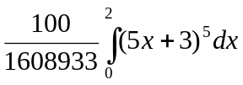

Find P(x>1) 6marks

(b) Define probability Measure indicating relevant properties. 4marks
(c) The probability function of a random variable x is given by f(x)
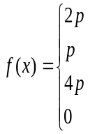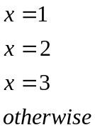

Where p is a constant, find

- The value of p
- P(0≤x<3)
- P(x>1) 4marks
2(a) Define a continuous random variable on a probability space 7marks
2(b) The length of life measure in hours of a certain rare
type of insect is a random variable x with portability density function
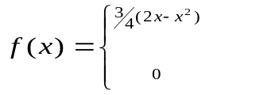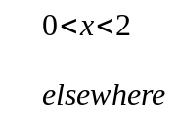
If the amount of food measured in milligrams consumed in a life time by such an insect defined by the function 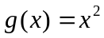,
where x is the length of life measured in hours, find the expected amount of food that will be consumed by an insect of this type. 7marks

3(a) In an experiment involving tossing a fair coin thrice, if t is a random variable representing the number of head that turns up.
Draw a graph representing the distribution function of this experiment? 6marks

- In the experiment 3(a) , if y is a random variable representing the number of tails that turns up.
- Find the probability of having two tails
- Find the probability of having no tail
- Find the probability of having three head
(iv) Find the probability of having a single head 4marks

- Find the value of the constant K such that the integral of
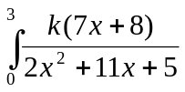 is a pdf
4marks

4(a) Define Central limit theorem for independently and identically distributed (iid) random variable X and determine its moment generating function(Mgf). 4marks

(b) The joint density function of two continuous random variables x and y is
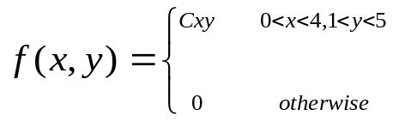

(i). Find the value of the constant C 3marks
(ii). Find 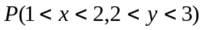 4marks
(iii). Find 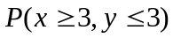. 3marks

5 A pair fair dice is tossed. We obtain the finite equiprobable space consisting of the 36 ordered pairs of numbers between 1 and 6, given as
S = ((1,1), (1,2), . . . , (6,6)}. Let X assign to each point (a,b) in S, the maximum of its numbers i.e X(a,b) = max(a,b). Then
- Show that X is a random variable with the image set X(S) = {1, 2, . . . , 6} 2marks
- Compute the distribution f(x) 2marks
- Compute also the expected value of X 2marks
- Compute the expected value of Y, if Y assigns to each point (a,b) in S, the sum of its numbers a+b. 4marks
- Indicate the g(y) graphically. 4marks
6 (a) State and prove CHEBYSHEV’S INEQUALITY for a continuous
random variable. 7marks

(b) State and prove DEMOVRE’S THEOREM 7marks

7. (a) Show that the sequence 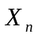 of random variable  is said to converge
(i) In mean square to Random Variable X. 4marks
(ii) With probability one almost surely to a constant c. 4marks

(b) State and Prove Central limit Theorem. 6marks

